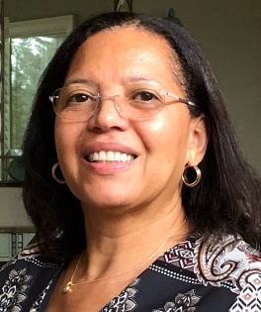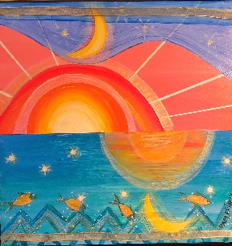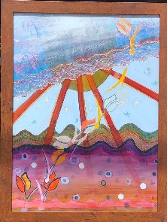
Pam Friday – Artist

Pam Friday has been creating art for over 50 years. She began her studies in grade school and then attended the famed Fiorello H. LaGuardia High School of Music & Art in New York City. She continued her studies at Springfield College (Springfield, MA) and at the University of Massachusetts (Amherst, MA) where she received a Bachelor of Fine Arts Degree. She also studied at Howard University (Washington DC), The Art Students League (NY), The New York Academy of Art (NY), AVA Gallery -Landscape Painting (NH), and the Summer Mural Programs (Springfield MA). She was an art teacher in the New York City public & private school systems, followed by a long career in educational software sales. These careers helped to finance her love of art. She recently retired and relocated from her home in New York City to Melbourne, Florida and can now spend more time creating art.

Studying drawing and painting as a young woman in college and beyond, opened her horizons to more culturally-specific expressions of contemporary art and the Black community. She studied with Nelson Stevens, a prominent member of the famous AfriCOBRA (African Commune of Bad Relevant Artists) group. She participated in summer mural programs with Stevens in Springfield, Mass. Her art became bolder and evolved into more of an expression her own history, and African American heritage. The paintings focused on figures, patterns, hard edge, geometric forms, and bright colors.

Over the last 20 years, the shapes have become freer and the elements of collage have been incorporated into the paintings. Acrylic paint is her medium of choice on board or canvas. Her artwork often incorporates the original drawing on paper into the work. She feels that the initial vibe of a sketch added to the painting rather than recreating it, keeps the freshness of the idea and image.

Her art is influenced by life experiences that combine mind, body, and spirit. She has learned to re-awaken her artist soul and paint her deepest feelings. Her paintings speak to her and she listens and responds with a brush and color. She believes in letting her paintings lead her where they need to go.

You will often see a golden line in the sky in much of her work. This symbolizes God or a higher power, as she believes - no painting is created alone. Figures, sky, land, and water are frequent themes in her work as well as African patterns.

She has participated in over 30 exhibits in New York City, created artwork for a book cover (“Notes to Make the Sound Come Right” by T.J. Anderson III) and is now a member and exhibitor of the Strawbridge Art League & Gallery in downtown Melbourne, FL,

347-563-8063
Fridayart2@gmail.com
fb.me/pamfridayart

