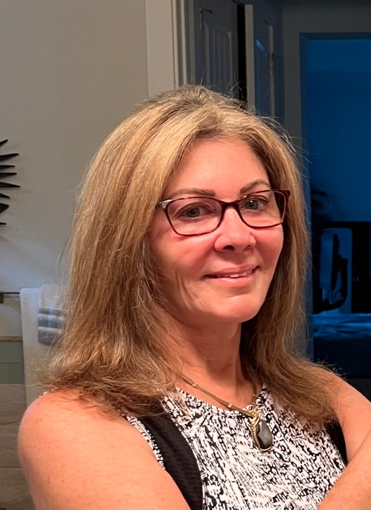
www.jewelrydesignsbymarchese.com
321-794-9679

About the Artist

Deborah Marchese is a local artist out of Melbourne Beach, Florida specializing in Jewelry making and design. Her pieces are on display in local Art Galleries and at Art Shows throughout Florida. She also has her work available on her website at www.jewelrydesignsbymarchese.com. Her unique pieces are created using a variety of techniques including lapidary, wire wrapping, silversmithing, intarsia, chainmaille, and filigree.

Deborah grew up in Sparta, New Jersey, where she attended high school and college. She was the second of four children. Upon graduation from college, she relocated to Cocoa Beach and entered the corporate world while retaining her true love and passion for jewelry making and design. She entered the nuclear energy field where she worked in various supervisory roles for 25 years. Upon her retirement in 2005 she relocated back to the Melbourne Beach area where she was able to focus on her passion, jewelry making and designing. Deborah is a member of several rock and gem clubs and societies. She is a student at William Holland School of Lapidary Arts in Georgia where she attends yearly sessions. Deborah is married with three sons, three grandsons and one granddaughter. Her other interests include football, archery, and travel. She was a competitive archer until injuries required her to give up competitive shooting in 1998.

About the Work

Deborah’s creations are only created from quality materials, using only 14K gold filled wire, and Sterling Silver. For her ear wires she only uses Hypoallergic Sterling Silver (Argentium) to allow everyone to be able to enjoy wearing her creations Most lapidary work is created by Deborah herself, she cuts the rough, shapes and polishes it to creates her cabochons. Her clasps are also of high quality allow for ease in putting on and removal. She is meticulous in selecting which stone to use. She won’t do creations the same because, “I want my creations to take on a life of its own.” Her love and passion for jewelry making and design can be seen in all her necklaces, pendants, rings, earrings and bracelets.

